1. **Purchased domain:**

The Smartzoo.net domain name has been purchased, and with the help of firebase hosting we are able to host our website at minimal cost for the project. The website currently has a login page for authentication, as well as different sections for each of the nodes we are focusing on.

1. **User Interface login page:**

The user authentication page was made using firebase authentication, allowing us to control who views the website and ensure that only authorized users are able to view and change the designated values for what the zoo animal parameters should be. This gives the website added security for these sensitive animals in ensuring that they are not disturbed from their environment by outside malicious entities. Since employees at the Fresno Chaffee Zoo are given their own work email, for this demonstration there was no need for a sign up feature for new users.

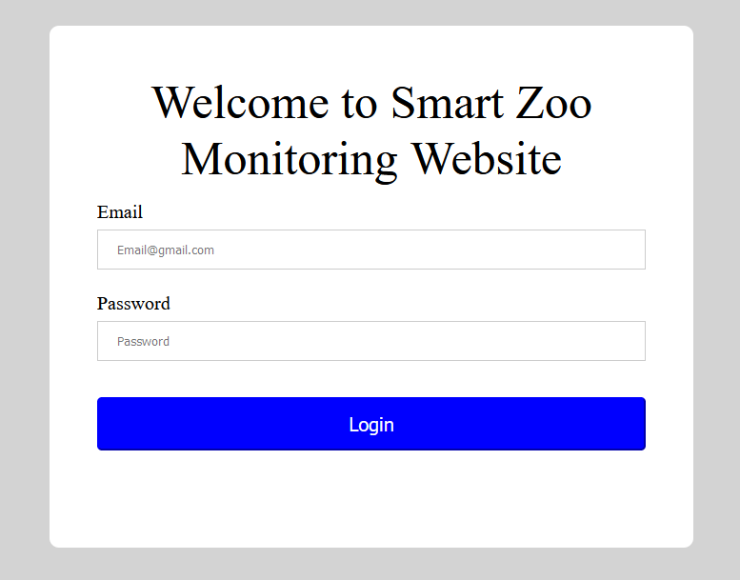

**Figure** : Login Page

1. **Homepage**

A homepage was implemented so that upon logging in, users would be able to see the current status for all the different animals at a quick glance. While this does not give an in-depth view of the actual values that are being collected on the sensors, it is a good indicator of how the animals are doing. This homepage also includes a weather forecast section so that users are able to get more details on the weather conditions. This weather is collected from OpenWeather, an API that sends data directly to the website which is broadcasted using javascript.

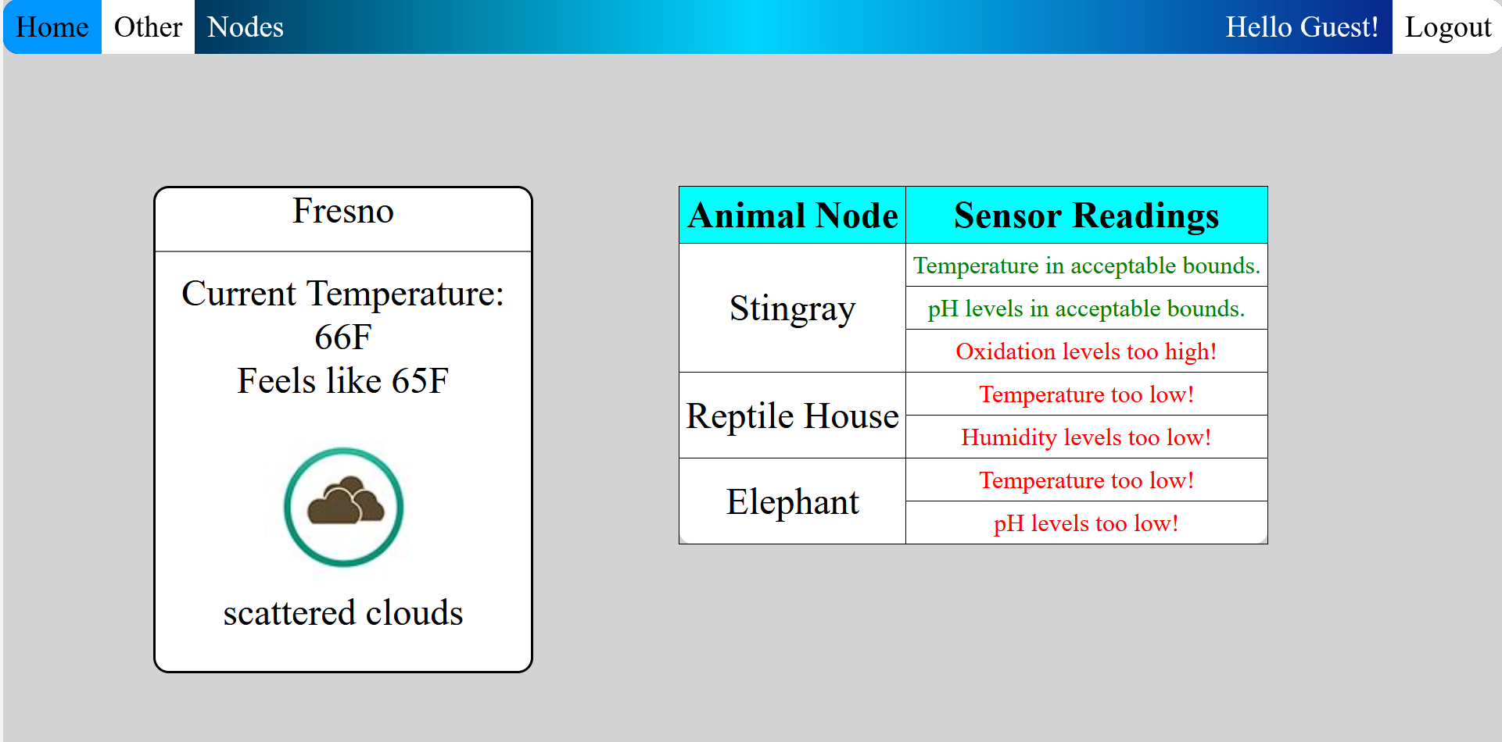

1. **Animal Pages**

With the project focusing on three different animal groups, three different web pages were made that could be accessed from the website's navigation bar. Each of the pages hold the sensors that are specific to their animal, such as stingrays having temperature, pH values, and oxidation. Reptile House nodes will display humidity and temperature, while elephants will have temperature and pH levels. Additionally, the stingray node will have a camera section for an active viewing of the stingrays.

All nodes will have a graph showing the previous values over a 24-hour period so that zookeepers can keep track of the trend of the values. All nodes will also have a section to designate desired values which will turn the actuators on to modify the enclosures in real time to match the desired values.

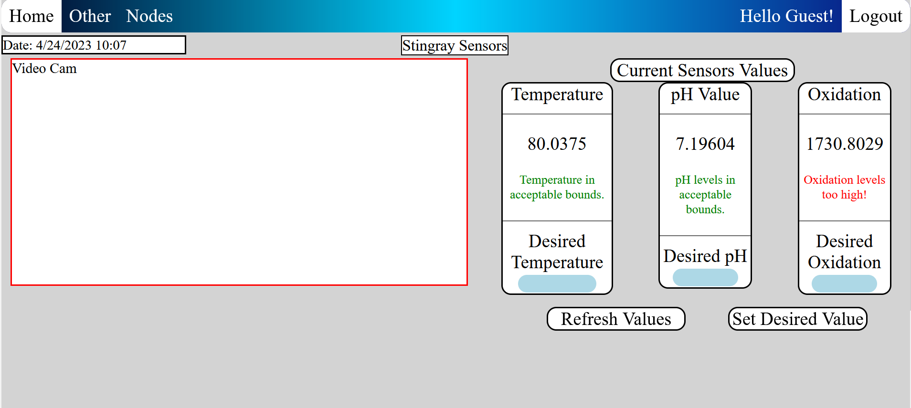

**Figure**  Stingray sensors

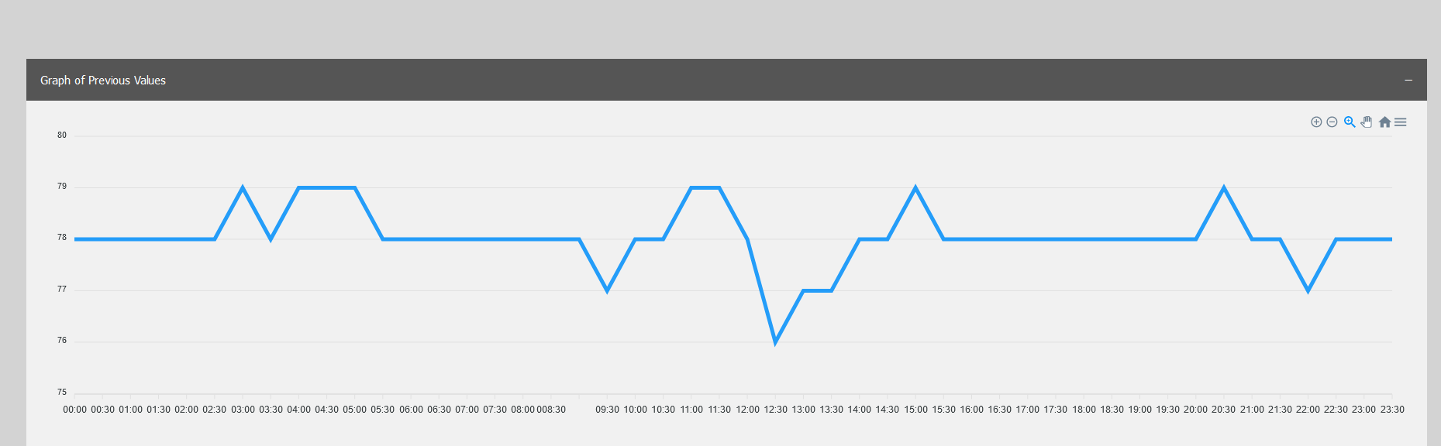

**Figure** Stingray Temperature graph over a 24-Hour period.

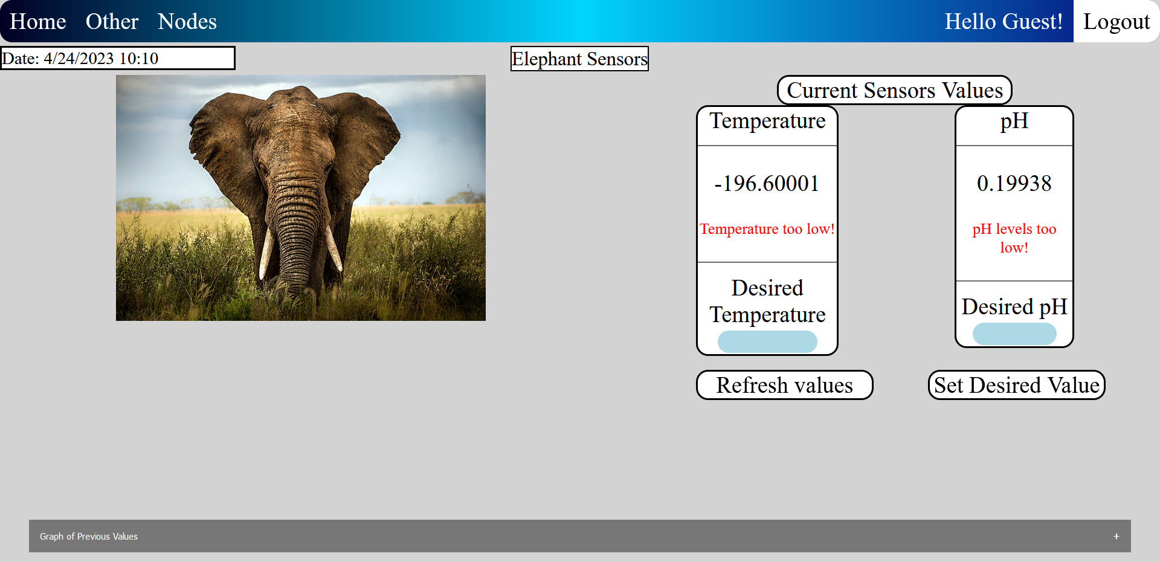

**Figure** Elephant Sensor webpage, showing the difference between the two of them.